**PROJECT REPORT**

For

HOMOMORPHIC ENCRYPTION

Prepared by

|  |  |  |
| --- | --- | --- |
| **Specialization** | **SAP ID** | **Name** |
| CCVT(H) | 500083041 | Manil Munjal |



Department of Systemics

School Of Computer Science

UNIVERSITY OF PETROLEUM & ENERGY STUDIES,

DEHRADUN- 248007. Uttarakhand

**Project Title**

HOMOMORPHIC ENCRYPTION

**Background**

Homomorphic Encryption is a kind of encryption that permits calculation to be performed on ciphertext, delivering an encoded outcome which, when unscrambled, is equivalent to on the off chance that the calculation were performed on plaintext. It was first presented in 1978 by Rivest, Adleman, and Dertouzos. Homomorphic Encryption[1] is a progressive thought in the area of cryptography, as it permits information to be handled while never uncovering the plaintext, consequently offering an elevated degree of protection and security.

At first, Homomorphic Encryption was thought of as absolutely hypothetical, as it was computationally illogical. In any case, with the progression of innovation and the improvement of new calculations, Homomorphic Encryption has turned into a useful and promising answer for different true applications, for example, secure information sharing, secure calculation on cloud servers, and secure AI.[5]

Homomorphic encryption is a cryptographic method that allows computations to be performed on encrypted data without the need for decryption. It has its origins in the field of cryptography, which is concerned with securing communications and protecting data from unauthorized access. In the early days of cryptography, encryption was primarily used to protect communications from interception by adversaries. As technology advanced and computing power increased, new methods were developed to protect data at rest and in transit. One of these methods is homomorphic encryption, which has the potential to provide strong security guarantees while still allowing computations to be performed on sensitive data. The development of homomorphic encryption has been driven by the need to protect data in a variety of applications, including cloud computing, artificial intelligence, financial services, healthcare, and government and defense. Despite its potential benefits, homomorphic encryption is still a relatively new and evolving technology, and there are challenges that need to be addressed in order to make it practical and effective for real-world use cases.

Homomorphic Encryption is comprehensively grouped into two classifications: Completely Homomorphic Encryption (FHE)[1] and Somewhat Homomorphic Encryption (PHE). In FHE, any calculation can be performed on the encoded information, while in PHE, just specific kinds of calculations are permitted, like expansion or duplication.

The expected utilizations of Homomorphic Encryption are huge and incorporate secure information partaking in ventures like medical care and money, secure calculation on cloud servers, and secure AI [5], to give some examples. In any case, Homomorphic Encryption is as yet a functioning area of exploration, and there are progressing endeavors to work on its productivity and versatility, making it more available and broadly material in different spaces.

**Abstract**

Homomorphic encryption is a cryptographic strategy that permits calculations to be performed on scrambled information, without the need to decode it first. At the end of the day, it empowers information to be safely handled while as yet being kept hidden. This is accomplished through a numerical activity that changes scrambled information so that the consequence of performing calculations on the changed information is identical to the consequence of playing out similar calculations on the first decoded information. Homomorphic encryption has various applications in regions, for example, distributed computing, AI, and security safeguarding information examination, where it is basic to safeguard delicate data while considering calculations to be performed on that data. Be that as it may, homomorphic encryption is as yet an area of dynamic innovative work, with many difficulties to be survived, including execution constraints and security concerns.

Homomorphic encryption is a perplexing and strong cryptographic procedure that can possibly reform the manner in which we process and break down information, especially in settings where protection and security are foremost. The fundamental thought behind homomorphic encryption is to empower calculations to be performed on scrambled information, without requiring the decoding of the information first. This is accomplished by changing the encoded information such that jam its importance and design, while additionally permitting numerical tasks to be performed on the scrambled information. The consequence of these activities is a scrambled result that compares to the aftereffect of playing out similar procedure on the decoded information.

Homomorphic encryption is commonly arranged into three classifications: completely homomorphic encryption (FHE), somewhat homomorphic encryption (PHE), and to some degree homomorphic encryption (SHE). FHE considers any calculation to be performed on scrambled information, while PHE and SHE just take into account explicit kinds of calculations to be performed on the encoded information. FHE is the most impressive yet additionally the most computationally costly type of homomorphic encryption, while PHE and SHE are by and large more proficient however less adaptable.

Homomorphic encryption has various likely applications in a great many fields. For instance, in distributed computing, homomorphic encryption can be utilized to safeguard delicate information put away on far off servers, while as yet permitting calculations to be performed on that information. In AI, homomorphic encryption can be utilized to safeguard the protection of client information while as yet empowering the preparation of AI models on that information. In finance, homomorphic encryption can be utilized to perform secure calculations on scrambled monetary information, without uncovering delicate data to unapproved parties.

In spite of its numerous expected advantages, homomorphic encryption additionally has a provokes that should be tended to. One of the greatest difficulties is execution, as homomorphic encryption can be computationally costly and slow. This can restrict its reasonableness in certain applications, especially those that call for genuine investment or close ongoing handling. One more test is security, as homomorphic encryption is defenseless against particular kinds of assaults, for example, side-channel assaults and timing assaults. In any case, progressing innovative work in the field of homomorphic encryption are assisting with tending to these difficulties and work on the general proficiency and security of this strong cryptographic method.

**Introduction**

Homomorphic encryption is a cutting-edge technology that enables secure computation on encrypted data. In traditional encryption, data is encrypted and then decrypted before being processed. However, with homomorphic encryption, data can be encrypted and still be processed without decryption. This is done by converting data into ciphertext and performing computations on the ciphertext. Homomorphic encryption is a powerful tool for securing sensitive data, and it has significant implications for a variety of industries and applications.

Homomorphic encryption was first proposed in the 1970s, but it wasn't until the 2000s that it began to gain significant attention. In 2009, Craig Gentry proposed the first fully homomorphic encryption scheme, which enabled arbitrary computations to be performed on encrypted data. However, the computational overhead of fully homomorphic encryption is significant, and it was not until the development of more efficient algorithms that it became practical.

There are two types of homomorphic encryption: partially homomorphic encryption (PHE) and fully homomorphic encryption (FHE). PHE only allows for specific computations, such as addition or multiplication, while FHE allows for any computation to be performed on encrypted data. FHE is more complex and resource-intensive than PHE, but it is also more powerful. PHE is simpler and easier to implement, but less versatile.

Homomorphic encryption has a wide range of applications. One of the most promising applications is in the field of cloud computing. With homomorphic encryption, data can be processed in the cloud without the need to decrypt it, which means that data remains secure and private even when it is being processed by third-party servers. This has significant implications for industries that require secure and private data processing, such as healthcare, finance, and government.

Another potential application of homomorphic encryption is in privacy-preserving data analysis. With homomorphic encryption, data can be analyzed without revealing the underlying data. This means that data can be shared between different organizations without compromising privacy. This has significant implications for industries that require collaboration and data sharing, such as research and development.

Homomorphic encryption also has potential applications in secure machine learning. With homomorphic encryption, machine learning models can be trained on encrypted data, which means that sensitive data remains secure and private even during the training process. This has significant implications for industries that require machine learning and artificial intelligence, such as healthcare, finance, and cybersecurity.

Despite its potential, homomorphic encryption still faces significant challenges. One of the biggest challenges is the computational overhead of fully homomorphic encryption. Fully homomorphic encryption requires significant computational resources, and it can be slow and inefficient. Another challenge is the need for more efficient algorithms. While there have been significant advances in homomorphic encryption algorithms in recent years, there is still a need for more efficient algorithms that can scale to larger datasets.

In conclusion, homomorphic encryption is a powerful tool for securing sensitive data and enabling secure computation on encrypted data. It has significant implications for a wide range of industries and applications, from cloud computing and privacy-preserving data analysis to secure machine learning. While there are still challenges to be overcome, the potential of homomorphic encryption is enormous, and it is likely to play an increasingly important role in the future of data security and privacy.

**Application:**

Homomorphic [4] encryption has numerous potential applications in a variety of fields where data privacy and security are paramount. Here are some examples of how homomorphic encryption can be applied in different contexts:

Cloud computing: Homomorphic encryption can be used to protect sensitive data stored on remote servers, while still allowing computations to be performed on that data. This makes it possible for cloud providers to offer more secure and privacy-preserving services to their customers.

Machine learning: Homomorphic encryption [4] can be used to protect the privacy of user data while still enabling the training of machine learning models on that data. This makes it possible for organizations to share data for research purposes without compromising the privacy of their users.

Financial services: Homomorphic encryption [4] can be used to perform secure computations on encrypted financial data, without revealing sensitive information to unauthorized parties. This makes it possible for financial institutions to share data for compliance and regulatory purposes while maintaining the privacy of their customers.

Healthcare: Homomorphic encryption can be used to protect the privacy of medical data, while still allowing healthcare providers to perform analytics and research on that data. This makes it possible for medical researchers to analyze large amounts of data without compromising the privacy of patients.

Government and defense: Homomorphic encryption can be used to protect sensitive data in government and defense applications, such as secure communications and data sharing. This makes it possible for governments to share information securely and protect against cyber attacks.

**Uses:**

Secure information sharing: Homomorphic Encryption can be utilized to safely share delicate information, like clinical records, monetary data, or individual data, between various gatherings without uncovering the plaintext. This could be especially helpful in enterprises like medical services or money, where information security is of most extreme significance.

Secure calculation on cloud servers: Homomorphic Encryption can permit information to be handled on cloud servers while keeping it encoded, consequently giving an elevated degree of safety and protection. This could be especially valuable for organizations or associations that need to perform information examination on cloud servers without uncovering the plaintext.

Secure AI [5] : Homomorphic Encryption [4] can be utilized to safely prepare AI models on encoded information, while never uncovering the plaintext. This could be especially helpful for enterprises like medical services or money, where delicate information should be utilized for AI without compromising security.

Secure democratic: Homomorphic Encryption can be utilized to get web based casting a ballot frameworks by permitting votes to be scrambled and counted while never uncovering the plaintext. This could assist with forestalling political decision misrepresentation and guarantee the uprightness of the democratic cycle.

Secure reevaluating of calculation: Homomorphic Encryption can permit information to be handled by outsider suppliers without uncovering the plaintext, giving an elevated degree of safety and protection. This could be especially valuable for organizations or associations that need to re-appropriate calculation to outsider suppliers without compromising information protection.

**Literature Review**

Homomorphic encryption is a cryptographic method that empowers calculations to be performed on encoded information without the requirement for decoding. This method has various applications in fields, for example, distributed computing, AI, and monetary administrations. Homomorphic encryption can be arranged into three classes: completely homomorphic encryption (FHE), to some extent homomorphic encryption (PHE), and to some degree homomorphic encryption (SHE). FHE is the most remarkable type of homomorphic encryption, as it considers any calculation to be performed on encoded information, while PHE and SHE just take into consideration explicit kinds of calculations to be performed.

One of the earliest and most notable homomorphic encryption plans is the RSA-based plot proposed by Rivest, Adleman, and Dertouzos in 1978. Notwithstanding, this plan is just to some extent homomorphic and restricted to a particular class of calculations. In 2009, Craig Upper class presented the first completely homomorphic encryption conspire, which depended on ideal grids. This plan was pivotal, yet it was additionally computationally costly and not pragmatic for most applications.

From that point forward, there have been various advances in homomorphic encryption, including the improvement of additional effective and reasonable plans. One such plan is the BGV conspire proposed by Brakerski, Upper class, and Vaikuntanathan in 2011. This plan depends on ideal cross sections and is equipped for playing out a large number of calculations on encoded information. One more proficient plan is the TFHE plot proposed by Chillotti, Gama, and Georgieva in 2016. This plan depends on the ring learning with mistakes (RLWE) [2] issue and is especially effective for parallel calculations.

Homomorphic encryption has various applications in different fields. In distributed computing, homomorphic encryption can be utilized to safeguard delicate information put away on far off servers, while as yet permitting calculations to be performed on that information. In AI, homomorphic encryption can be utilized to safeguard the protection of client information while as yet empowering the preparation of AI models on that information. In monetary administrations, homomorphic encryption can be utilized to perform secure calculations on encoded monetary information, without uncovering delicate data to unapproved parties. In medical services, homomorphic encryption can be utilized to safeguard the security of clinical information, while as yet permitting medical services suppliers to perform examination and exploration on that information. In government and guard, homomorphic encryption can be utilized to safeguard delicate information in secure correspondences and information sharing.

While homomorphic encryption has various possible advantages, there are additionally difficulties to be tended to. One of the greatest difficulties is execution, as homomorphic encryption can be computationally costly and slow. One more test is security, as homomorphic encryption is defenseless against specific sorts of assaults, for example, side-channel assaults and timing assaults. Continuous innovative work in the field of homomorphic encryption is pointed toward tending to these difficulties and working on the general productivity and security of this strong cryptographic procedure.

Homomorphic encryption is a cryptographic method that empowers calculations to be performed on encoded information without the requirement for decoding. This method has various applications in fields, for example, distributed computing, AI, and monetary administrations. Homomorphic encryption can be arranged into three classes: completely homomorphic encryption (FHE) [3], to some extent homomorphic encryption (PHE), and to some degree homomorphic encryption (SHE). FHE is the most remarkable type of homomorphic encryption, as it considers any calculation to be performed on encoded information, while PHE and SHE just take into consideration explicit kinds of calculations to be performed.

One of the earliest and most notable homomorphic encryption plans is the RSA-based plot proposed by Rivest, Adleman, and Dertouzos in 1978. Notwithstanding, this plan is just to some extent homomorphic and restricted to a particular class of calculations. In 2009, Craig Upper class presented the first completely homomorphic encryption [3] conspire, which depended on ideal grids. This plan was pivotal, yet it was additionally computationally costly and not pragmatic for most applications.

From that point forward, there have been various advances in homomorphic encryption, including the improvement of additional effective and reasonable plans. One such plan is the BGV conspire proposed by Brakerski, Upper class, and Vaikuntanathan in 2011. This plan depends on ideal cross sections and is equipped for playing out a large number of calculations on encoded information. One more proficient plan is the TFHE plot proposed by Chillotti, Gama, and Georgieva in 2016. This plan depends on the ring learning with mistakes (RLWE) issue and is especially effective for parallel calculations.

Homomorphic encryption has various applications in different fields. In distributed computing, homomorphic encryption can be utilized to safeguard delicate information put away on far off servers, while as yet permitting calculations to be performed on that information. In AI, homomorphic encryption can be utilized to safeguard the protection of client information while as yet empowering the preparation of AI models on that information. In monetary administrations, homomorphic encryption can be utilized to perform secure calculations on encoded monetary information, without uncovering delicate data to unapproved parties. In medical services, homomorphic encryption can be utilized to safeguard the security of clinical information, while as yet permitting medical services suppliers to perform examination and exploration on that information. In government and guard, homomorphic encryption can be utilized to safeguard delicate information in secure correspondences and information sharing.

While homomorphic encryption has various possible advantages, there are additionally difficulties to be tended to. One of the greatest difficulties is execution, as homomorphic encryption can be computationally costly and slow. One more test is security, as homomorphic encryption is defenseless against specific sorts of assaults, for example, side-channel assaults and timing assaults. Continuous innovative work in the field of homomorphic encryption is pointed toward tending to these difficulties and working on the general productivity and security of this strong cryptographic procedure.

**Research Gap**

"Propelling the Province of Homomorphic Encryption: Further developing Proficiency, Security, and Pertinence"

This examination cap features the need to propel the province of Homomorphic Encryption by tending to a few key exploration challenges. These difficulties incorporate working on the effectiveness and adaptability of Homomorphic Encryption calculations, upgrading the security and protection of Homomorphic Encryption conspires, and growing the appropriateness of Homomorphic Encryption to new areas and use cases.

In particular, this examination cap calls for research endeavors to foster more proficient and versatile Homomorphic Encryption [3] calculations that can lessen computational above and empower useful execution in distributed computing and other asset compelled conditions. It additionally features the need to upgrade the security and protection of Homomorphic Encryption plans, for example, by investigating new cryptographic natives and guards against side-channel assaults.

Furthermore, this exploration cap calls for endeavors to grow the pertinence of Homomorphic Encryption to new spaces and use cases, for example, secure AI [5], secure information sharing, and secure reevaluating of calculation. This could include growing new Homomorphic Encryption plots that can uphold a more extensive scope of calculations, or investigating new ways to deal with incorporating Homomorphic Encryption [4] with existing information handling and examination pipelines.

**Problem Statement**

In spite of the likely advantages of Homomorphic Encryption in giving secure calculation on cloud servers, its reasonable execution faces a few difficulties. These incorporate high computational above, expanded capacity necessities, and impediments on the kinds of calculations that can be performed. Subsequently, there is a need to investigate more proficient and versatile Homomorphic Encryption calculations that can beat these restrictions and empower reasonable execution in distributed computing conditions.

**Objectives:-**

* To Implement homomorphic encryption
* ​To implement relinearization
* To implement encryption algorithms

**Purpose of the Project**

The primary purpose of homomorphic encryption is to enable secure computation on encrypted data. With traditional encryption methods, data must be decrypted before it can be processed, which can create vulnerabilities in data security. Homomorphic encryption allows for data to remain encrypted even while it is being processed, which significantly enhances data security and privacy

**SWOT Analysis**

Strengths:

* Enhances data security and privacy by enabling secure computation on encrypted data.
* Has a wide range of potential applications, such as cloud computing, secure machine learning, privacy-preserving data analysis, and blockchain-based systems.
* Enables data to remain encrypted while it is being processed, reducing the risk of data breaches and ensuring data privacy.
* Has the potential to revolutionize the way that data is processed, analyzed, and shared.

Weaknesses:

* Homomorphic encryption is still a relatively new technology, and there is a lack of widespread adoption and understanding.
* Homomorphic encryption algorithms can be computationally expensive and require significant processing power, which can be a barrier to adoption in some use cases.
* There are limitations to the type of computations that can be performed on encrypted data, which can limit the scope of applications.

Opportunities:

* The increasing need for data security and privacy in industries such as healthcare, finance, and government creates opportunities for the adoption of homomorphic encryption.
* Advances in computing power and algorithm development may lead to more efficient and scalable homomorphic encryption solutions, expanding the scope of applications.
* The rise of blockchain-based systems and the need for privacy-preserving transactions and smart contracts creates opportunities for the adoption of homomorphic encryption.

Threats:

* Other emerging technologies such as quantum computing could potentially render homomorphic encryption obsolete by breaking the encryption.
* Adoption of homomorphic encryption could be limited by the cost of computing resources required to implement the technology, especially in resource-constrained environments.
* There may be legal and regulatory challenges associated with the use of homomorphic encryption, especially in industries with strict data privacy and security regulations.

**Methodology**

Homomorphic encryption is a cryptographic method that lets in computations to be accomplished on encrypted statistics without requiring decryption. The method at the back of homomorphic encryption entails transforming the authentic plaintext facts into an encrypted form, while maintaining its mathematical homes that enable computations to be accomplished on it. this is done by means of the usage of mathematical capabilities that allow encrypted facts to be added, subtracted, accelerated, and greater, without requiring the decryption of the data. To carry out computations on the encrypted records, the suitable mathematical features are applied to the encrypted facts, ensuing in an encrypted output. The output can then be decrypted to expose the end result of the computation, even as the authentic encrypted statistics remains blanketed. The methodology for homomorphic encryption continues to conform as new techniques and algorithms are advanced to enhance its performance and protection.

**Implementation**

Key generation: The first step in implementing Homomorphic Encryption is to generate a public key and a secret key. The public key is used to encrypt the plaintext data, while the secret key is used to decrypt the ciphertext data.

Encryption: Once the keys are generated, the plaintext data is encrypted using the public key. This is typically done using a mathematical function that transforms the plaintext into ciphertext while preserving the ability to perform computations on the encrypted data.

Relinearlization: Relinearization enables calculations to be done on encrypted data while keeping its correctness and security, which is crucial for the efficiency and security of homomorphic encryption. Relinearization algorithms must be effective in order to minimise the computational burden associated with homomorphic encryption, and current research in this field is helping to make relinearization methods even more effective.

Homomorphic operation: The encrypted data can now be used to perform computations using homomorphic operations, which allow computations to be performed on the ciphertext data without decrypting it. Depending on the type of Homomorphic Encryption scheme being used, different types of operations may be supported, such as addition, multiplication, or comparison.

Decryption: Once the computation is complete, the ciphertext data can be decrypted using the secret key to obtain the result in plaintext form.

These are the result for the encryption technique

**Technology Stack**

* Python
* Libraries
* Encryption techniques (key generation)
* Relinearization

**Feasibility Study**

A practicality investigation of Homomorphic Encryption would normally include an examination of the specialized, monetary, and functional plausibility of executing Homomorphic Encryption in a particular application or climate.

Specialized practicality: This part of the possibility study would assess the specialized prerequisites and impediments of executing Homomorphic Encryption in the objective climate. This would include surveying variables, for example, the intricacy of the Homomorphic Encryption conspire being utilized, the computational above of the encryption cycle, and the similarity of the encryption interaction with existing information handling or investigation pipelines.

Monetary practicality: The financial achievability examination would evaluate the monetary expenses and advantages of executing Homomorphic Encryption in the objective climate. This would include assessing elements like the expense of getting and keeping up with the important equipment and programming foundation, the expected expense reserve funds from further developed information protection and security, and the possible profit from venture from executing Homomorphic Encryption.

Functional achievability: The functional possibility examination would assess the pragmatic contemplations and functional prerequisites of executing Homomorphic Encryption in the objective climate. This would include evaluating variables, for example, the accessibility of talented faculty to execute and deal with the Homomorphic Encryption process, the possible effect on existing information handling or investigation work processes, and the similarity of the encryption interaction with administrative prerequisites or industry norms.

**System analysis:**

System analysis for homomorphic encryption involves examining the technical, security, and practical considerations of implementing the encryption scheme. Here are some key aspects to consider:

Technical Analysis:

Homomorphic encryption requires significant computational resources, which may limit its applicability in some contexts. The efficiency of the encryption scheme can be evaluated in terms of its speed, computational complexity, and memory requirements. A thorough analysis of these factors is important in understanding the feasibility of the homomorphic encryption system in practical settings.

Security Analysis:

Homomorphic encryption is vulnerable to various types of attacks, including side-channel attacks, timing attacks, and power analysis attacks. A thorough security analysis should be conducted to evaluate the robustness of the encryption scheme against these attacks. This analysis should also consider the potential impact of an attack on the confidentiality and integrity of the encrypted data.

Practical Analysis:

Homomorphic encryption should be evaluated for its practicality in real-world settings. This includes examining factors such as the availability and compatibility of hardware and software, the ease of implementation and maintenance, and the cost of the system. A practical analysis should also consider the impact of the encryption scheme on the overall system performance and user experience.

Use Case Analysis:

Homomorphic encryption has a variety of potential use cases, including secure cloud computing, data sharing, and secure machine learning. An analysis of the specific use case for the homomorphic encryption system is important to understand the specific requirements and constraints that need to be considered in the system design and implementation.

**Technical Design**

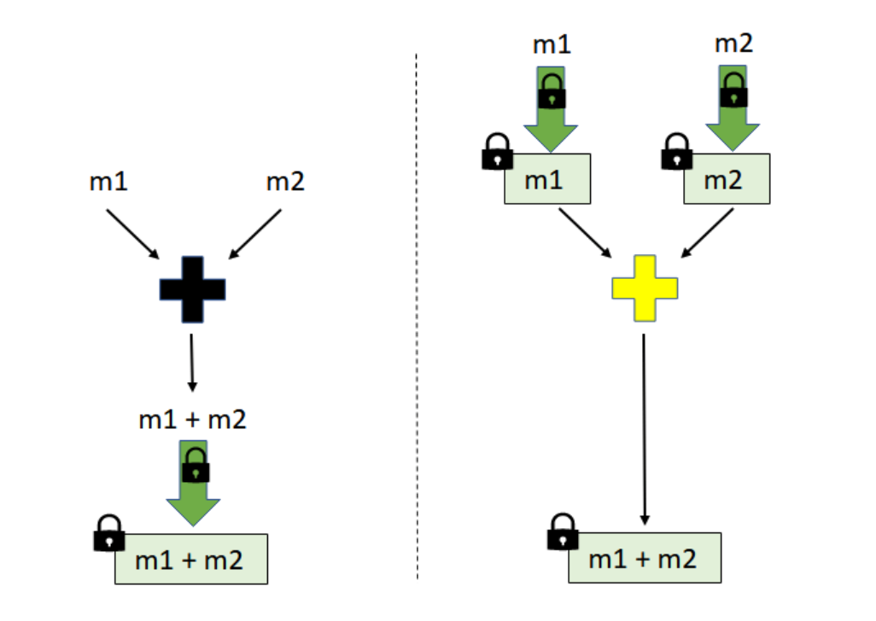

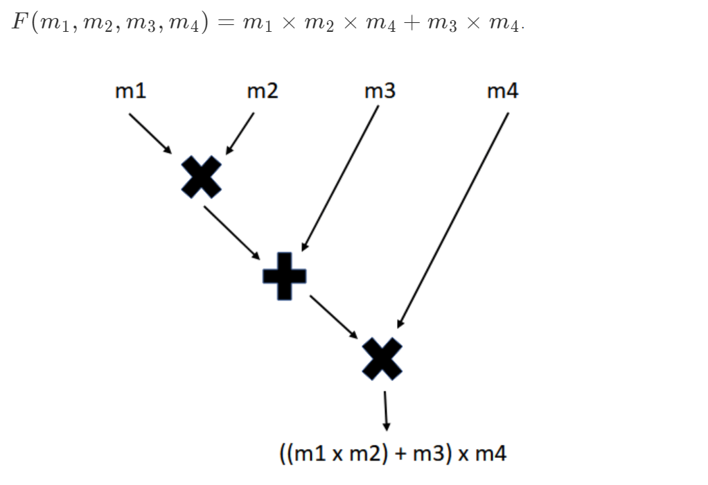

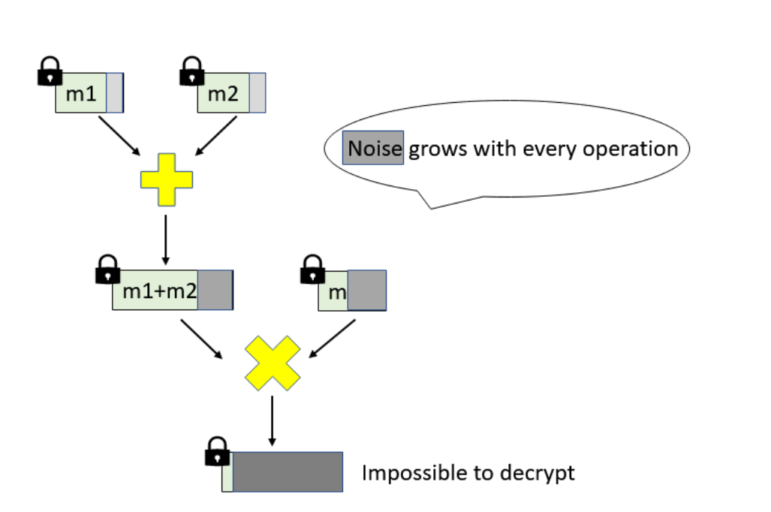

**Non-Functional Requirements**

* Security: Security is a critical software quality attribute for homomorphic encryption, as the technology is used to protect sensitive and confidential data. The software must be designed and implemented to provide strong encryption and prevent unauthorized access, tampering, or other security threats.
* Performance: Homomorphic encryption algorithms can be computationally intensive, and the software must be designed to minimize processing time and memory usage while maintaining accuracy and correctness. Performance is particularly important for real-time applications or those that require rapid processing of large datasets.
* Scalability: Homomorphic encryption algorithms must be able to scale to accommodate larger datasets and more complex computations. The software must be designed to support distributed computing and other techniques to improve scalability and performance.
* Usability: Homomorphic encryption algorithms are complex and may be difficult for non-experts to use. The software must be designed to provide a user-friendly interface and clear documentation to help users understand and effectively use the technology.

**Limitation:**

Despite the potential advantages of homomorphic encryption, there are a number of restrictions and difficulties that must be resolved. Its computational complexity is one of its key drawbacks, which might render it sluggish and ineffective for some applications. When compared to conventional computations on unencrypted data, homomorphic encryption computations are typically much slower.

Another drawback is the size of the ciphertext, which grows considerably as more homomorphic processes are carried out. Increased communication and storage costs may follow from this.

Additionally, attacks like timing and side-channel attacks can be used against homomorphic encryption. These assaults have the potential to compromise the system's security by leaking details about the encrypted data or the homomorphic processes being carried out.

**Conclusion and Future Scope**

The future extension for homomorphic encryption is tremendous, as the innovation can possibly upset the manner in which we process and break down information in a large number of uses. Here are a portion of the expected future improvements in homomorphic encryption:

Execution improvements: One of the essential hardships of homomorphic encryption is execution, as it will in general be computationally exorbitant and slow. Advancing exploration is revolved around developing more capable computations and strategies to chip away at the introduction of homomorphic encryption. This consolidates developing speedier hardware and programming executions, propelling the cryptographic locals used in homomorphic encryption, and researching new mathematical strategies to reduce the computational multifaceted design of homomorphic encryption.

Security enhancements: Another trial of homomorphic encryption is security, as it is defenseless against specific kinds of attacks, for instance, side-channel attacks and timing attacks. Advancing exploration is revolved around becoming more secure homomorphic encryption plans, chipping away at the strength of homomorphic encryption against various kinds of attacks, and developing new cryptographic strategies to overhaul the security of homomorphic encryption.

Standardization: As homomorphic encryption ends up being even more extensively embraced, there is a prerequisite for standardization to ensure interoperability between different executions and to work with the improvement of new applications. Persistent undertakings are based on making standards and best practices for homomorphic encryption, similar to the Homomorphic Encryption Standardization Consortium (HESC).

New applications: Homomorphic encryption might potentially engage new applications in districts like data assurance, security, and assessment. Ceaseless investigation is examining new applications for homomorphic encryption, for instance, secure multiparty estimation, secure data sharing, and insurance defending man-made intelligence.

Interdisciplinary investigation: Homomorphic encryption is a multidisciplinary field that requires expertise in math, cryptography, programming, and various disciplines. Constant assessment is revolved around joining experts from different fields to collaborate on becoming new homomorphic encryption plans and applications, as well as watching out for the challenges of execution and security

**Reference:**

[1]C. Gentry, "A Fully Homomorphic Encryption Scheme," PhD thesis, Stanford University, 2009.

[2]Z. Brakerski, C. Gentry, and V. Vaikuntanathan, "Fully Homomorphic Encryption from Ring-LWE and Security for Key Dependent Messages," in Proc. IEEE Symp. Security and Privacy, 2013, pp. 465-479.

[3]I. Chillotti, N. Gama, and M. Georgieva, "Faster Fully Homomorphic Encryption: Bootstrapping in Less Than 0.1 Seconds," in Proc. ACM SIGSAC Conf. Comput. Commun. Security, 2016, pp. 3-14.

[4]K. Lauter, "Homomorphic Encryption: From Mathematical Foundations to Cryptographic Applications," in Proc. International Congress of Mathematicians, 2018, pp. 3559-3578.

[5]S. Goldwasser, Y. Kalai, R. A. Popa, V. Vaikuntanathan, and N. Zeldovich, "How to Run Turing Machines on Encrypted Data," in Proc. ACM Symp. Theory of Computing, 2013, pp. 553-572.